6A^{th} Grade: Unit 3, Lesson 7

- How many units away are the points G and H from each other on the number line?
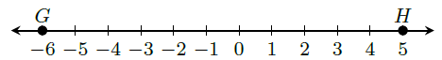
11

- A paycheck was deposited for $156 into a brand new savings account. The money was then used to pay a bill in the amount of $156. What does zero represent in this situation?
The account balance

- Which point is furthest from zero? Explain.
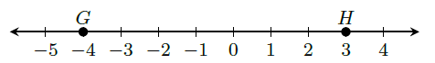
Point G is furthest from zero because it is 4 units away while point H is only 3 units away.

- What is the value of $\left|-10\right|$?

10

- Write the opposites of the values plotted on the number line.
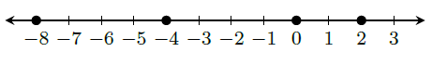
8, 4, 0, -2

- What are the numbers that have an absolute value of 9?

9 and -9

